<page_start no = 1>
<sol_start id=1>
1. P
<sol_end>

<sol_start id=2>
2. Pons
<sol_end>

<sol_start id=3>
3. Both 1 and 2
<sol_end>

<sol_start id=4>
4. Water
<sol_end>

<sol_start id=5>
5. Photo phosphorylation
<sol_end>

<sol_start id=6>
6. Decreased level of luteinizing hormone in the blood.
<sol_end>
<page_end>
<sol_start id=7>
7. woman × is conceived
<sol_end>
<sol_start id=8>
8. E
<sol_end>
<sol_start id=9>
9. It does not have glucose
<sol_end>
<sol_start id=10>
10. Lymph
<sol_end>
<sol_start id=11>
11. Centromere
<sol_end>
<sol_start id=12>
12. A, B and D are correct
<sol_end>
<sol_start id=13>
13. Meiosis and fertilization
<sol_end>
<sol_start id=14>
14. Absent of cell sap
<sol_end>
<sol_start id=15>
15. Both 1 and 2 are correct but statement 2 is not correct explanation of 1.
<sol_end>
<page_end>

<page_start no = 2>
<sol_start id=16>
<sub_id = 1>
16.(i) (a) Monohybrid cross
(b) Amniotic fluid
(c) Paternal twins
(d) Auditory nerve
(e) Concave lens
<sub_id end>
<sub_id = 2>
(ii) (a) True
(b) True
(c) True
(d) True
(e) False
<sub_id end>
<sub_id = 3>
(iii) (a) blood sugar
(b) Testosterone
(c) Larynx
(d) Cranium
(e) AIOS
<sub_id end>
<sub_id = 4>
(iv) (a) Alcohol consumption affects the cerebellum of the person, which is responsible over the controlling of skeletal muscles. Cerebellum is not able to control them and thus an alcoholic person walks clumsily.
(b) In some xerophytes leaves are reduced to spine in order to reduce the loss of water in the form of water vapoury by transpiration.
(c) Gametes must be produced by meiosis, such that each one get 23 chromsomes only, because after fertilization 46 chromsomes will be there and this number will remain constant.
(d)
(e) On entering the poorely lit room, a person feels blinded for sometime because light has divided the rodosphin which requires some time for combination.
<sub_id end>
<sub_id = 5>
(v) (a) Ovulation, Fertilization, Implantation, Gestation and Child birth.
(b) testes, sperm, sperm duct, semen, penis
(c)
(d) Homo erectus, Neanderthal man, Cro magnon, Homo sapiens
(e) Platelets, Thrombin, Fibrinogen, Fibrin
<sub_id end>
<sol_end>

<sol_start id=17>
<sub_id = 1>
17.(i)(a) Dendrites
(b) Axon
<sub_id end>
<sub_id = 2>
(ii) 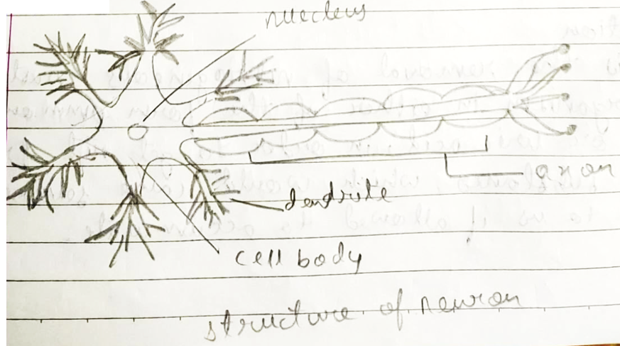
<sub_id end>
<sub_id = 3>
(iii) (a)Photo trophism
(b) Thigmo trophism
<sub_id end>
<sub_id = 4>
(iv) (a) Population
It refers to the count of people living in a particular area and in a particular period of time. These is termed as population.
(b) Tubectomy
It is one of the mechanical method for reducing population. It is the surgical removal of a particular part of oviduct or fallopian tube of female.
<sub_id end>
<sub_id = 5>
(v) (a) Auxins
These are sprayed in order to make the plant to grow properly as it is responsible for apical dominance.
(b) Gibberlins
These are used for stem elongation of plants.
(c) Abscasic acid
It is used for artificial ripening of fruit.
<sol_end>
<sub_id end>

<sol_start id=18>
<sub_id = 1>
18.(i) Exceretion
It is the removal of nitrogenous wastes by organism in either of the form ammonia, urea or uric acid, in order to get mid from tixic substances, which would cause severe harm to us if allowed to accumulate.
<sub_id end>
<sub_id = 2>
(ii) The substances that are selectively re absorbed are glucose, essantial salts like sodium chloride, or iodine, etc. This also includes absorbtion of water also.
<sub_id end>
<sub_id = 3>
(iii) (a) It is the not of different blood vessels that come to kidney for fill ration of blood and excreted harmful wastes.
(b) Bowman’s capsule is there for the process of ultrafiltration under high pressure. It is referred as ultrafiltration as it is three layer filtration
<sub_id end>
<sub_id = 4>
(iv) (a) PCT
It’s function is to absorb all essaintial substances like that of glucose, salt, like sodium chloride, sodium bicarbonate and iodine.
(b) Loop of henle
It is for re-absorbtion of water molecules and make the urine concentrated.
<sub_id end>
<sub_id = 5>
(v) Nephron is the structural functional unit of kidney.
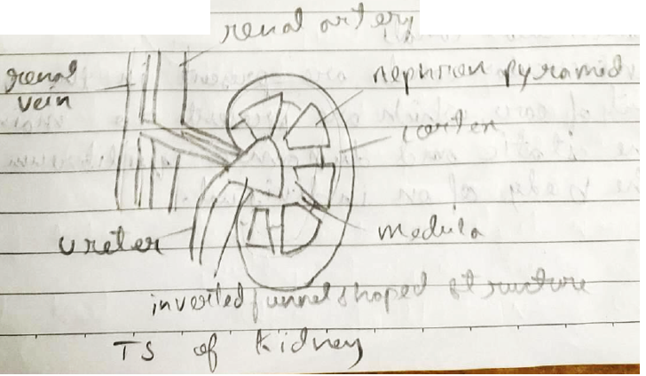
<sub_id end>
<sol_end>
<page_end>

<page_start no = 3>
<sol_start id=19>
<sub_id = 1>
19.(i) Adrenalline is called flight and fright and fight hormone as this hormone prepares the body to take immediate action against any kind of danger and stressful condition. Thus, it is called emergency hormone, which is released during emergency situations.
<sub_id end>
<sub_id = 2>
(ii) Feedback mechanism is the mechamism which controls the secretion of any kind of hormone by any endocrine gland, according t the need of body.
e.g. If basic metabolic rate decreases, pituitary gland makes thyroid gland to secrete thyroxine which stabilizes BMR and if this rate goes up pituitary makes thyroid gland to secrete less thyroxine.
<sub_id end>
<sub_id = 3>
(iii) (a) Thyroid – Thyroxine
(b) Pancreas – Insulin and glucagon
<sub_id end>
<sub_id = 4>
(iv) (a) Iris
Iris is the structure located in eye which controls the size of pupil according to the external lighting condition.
(b) Semicircular canals
Semicircular canals are present in the inner part of ear, which are present to maintain the static and dynamic equilibrium of the body of an individual.
<sub_id end>
<sub_id = 5>
(v) (a) Hypermetropia
It is also known as for sightedness, in which a person can see for objects clearly but finds it difficult to see near objects.
(b) Synapse
It is the fine gap present between the axon of one neuron and dendrites of other neuron, through which transmission of impulses from one neuron to another takes place.
(c) Taste buds
These are the buds present on the tongue, which helps us to understand different kinds of taste. E.g. sweetness, salting sourness, etc.
<sub_id end>
<sol_end>

<sol_start id=20>
<sub_id = 1>
20.(i) Evolution
The structural functional changes that leads to the improvement of any kind of functioning of body, in a period of time is called evolution.
<sub_id end>
<sub_id = 2>
(ii) 2 - Ramapathicus
5 – Cro magnon
<sub_id end>
<sub_id = 3>
(iii) Cranial capacity of ramapathicus is 500-600 cc
Cranial capacity of cro magnon is 1660 cc
<sub_id end>
<sub_id = 4>
(iv) Homo habilis
<sub_id end>
<sub_id = 5>
(v) (a)In atmosphere ozone layer is formed by the combination of nacent oxygen atoms.
(b) Ozone layer is essaintial for existence of life on earth as it absorbs all ultra violate radiation, which if reaches Earth can cause may diseases to human beings and other animals like skin cancer and blindness.
(c) Release of ozone depleting substance mainly chlorofluoro carbons or freon (CF₂Cl₂) must be reduced.
<sub_id end>
<sol_end>
<page_end>

<page_start no = 4>
<sol_start id=21>
<sub_id = 1>
21.(i) Root pressure
It is the hydrostatic pressure developed in the roots which is mainly to move the water in upward direction in roots, due to concentration of salute in it.
<sub_id end>
<sub_id = 2>
(ii) Rate of photosynthesis is low at low temperature because, much amount of radiant energy is not available.
Rate of photosynthesis is low at very high temperatures also, this is so because, photosynthetic apparatus is destroyed at high temperatures (solarization).
<sub_id end>
<sub_id = 3>
(iii) Green light is the least useful for the plants in photosynthesis.
This green rays of light are least absorbed by the plans, that’s why they are not useful for photosynthesis, this is the reason why plants look green.
<sub_id end>
<sub_id = 4>
(iv) Chlorophyll is one of the most important things for phosynthesis. For proving this, we take a vareigated plant which has yellow and green patches on it’s leaves yellow part lacks chlorophyll and green parts posses chlorophyll. By distarching plant and keeping it in sunlight and taking it’s leaves for taste, we found that the green patched area turns blue black showing positive starch test, showing that chlorophyll is essaintial for photosynthsis, yellow patched part got brown colour, showing negative starch test.
<sub_id end>
<sub_id = 5>
(v) (a) Purple inflated : 9
Purple constricted : 3
White inflated : 3
White constricted : 1
(b) Phenotype ratio :- 9 : 3 : 3 : 1
(c) Law of independ assortment
This states that in heterozygous condition during formation of gametes, genes assort independently, without blending and influencing each other.
<sub_id end>
<sol_end>

<sol_start id=22>
<sub_id = 1>
22. (i) Chromosomes
Chromosomes are the rod like structures that are formed by constriction and coiling of chromatin network during cell division, which consists of heredity material.
<sub_id end>
<sub_id = 2>
(ii)
Mitosis | Meiosis
·Two daughter cells are formed. | ·For daughter cells are formed.
·Daughter cells have same no. of chromosomes as that of parent cells. | ·Daughter cells have half the no. of chromosomes as that of parent cells.
·Takes place in body cells. | ·Takes place in formation of gametes.
·This occurs in whole life spon. | ·This occurs only in reproductivity active age.
<sub_id end>
<sub_id = 3>
(iii) Osmosis is the process being studied.
Root hairy are of immense importance for plants which provides extensive surface area for absobtion of water and minerals from soil.
<sub_id end>
<sub_id = 4>
(iv) External factors that affects the rate of transpiration are :
· Intensity of light.
· Humidity of the atmosphere.
<sub_id end>
<sub_id = 5>
(v)
 | Parts | Functions
1. | Ovary | Produces female gamete ova
2. | Oviduct | Carries the ova to the uterus.
3. | Vagina | It is the structure in which embryo develops and grows.
<sub_id end>
<sol_end>
<page_end>

